# Package Installation Guide

## Step by step guide to install and update packages

This section will detail the system requirements and UiPath packages to be available in the system to ensure that it executes the codes correctly. Follow the steps to install the package in UiPath studio:

**Step 1.** Click on Manage Packages.

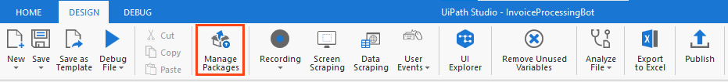

Figure 1 Manage Packages Ribbon Bar

**Step 2.** Search the package according to the project requirement.

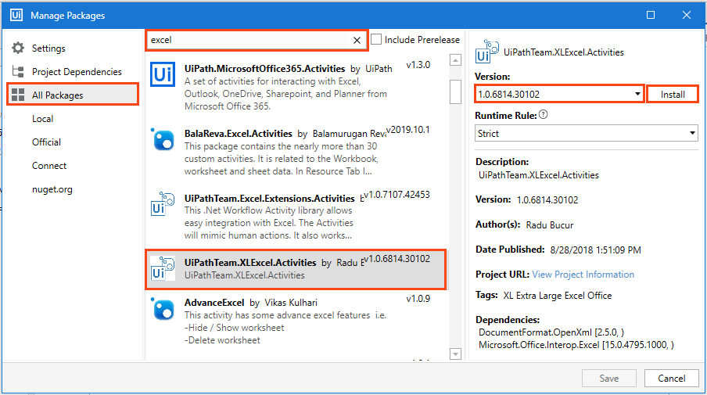

Figure 2 Package Installation

**Step 3:** Select the package and the version to be installed.

**Step 4:** Save the packages by clicking on the “Save” button.

## Viewing list of installed Packages

To view the packages used in code, right-click on the “Dependencies” option of “Project” panel and select “Manage” option (refer Figure 3).

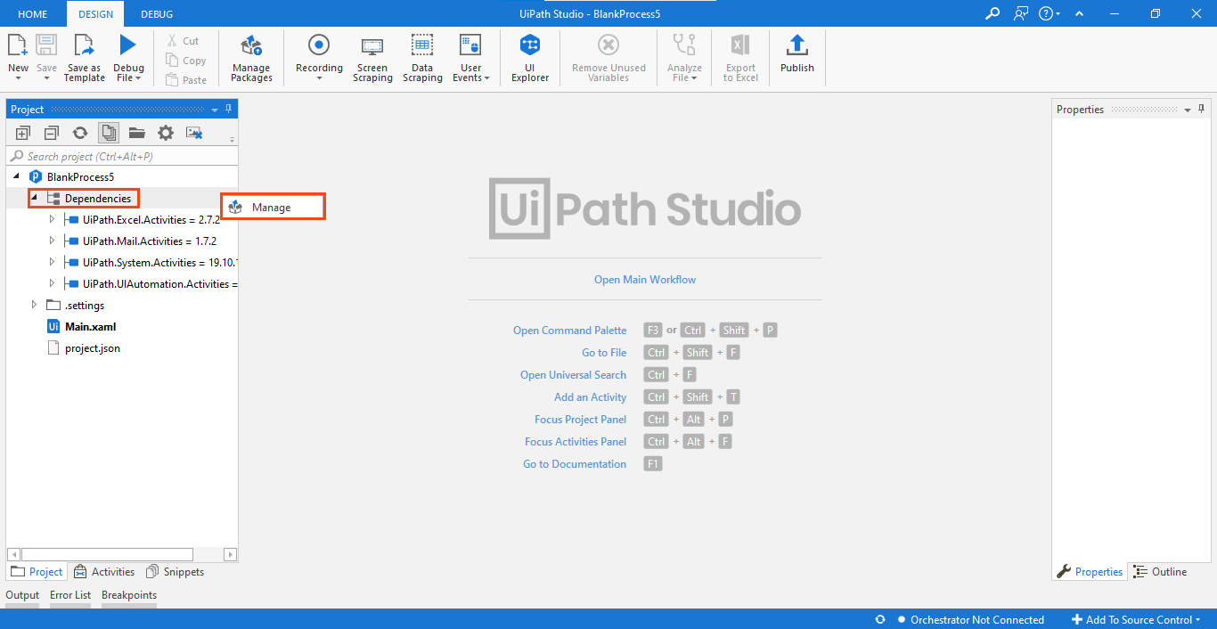

Figure 3 Installed Packages List

Note: For the codes which involve browser usage, the browser should have its extension installed. You can install an extension from the 'Tools' section of UiPath Studio.

# Advanced Projects

## Email Categorization Robot

The code comprises of four packages (refer Table 6), and they must be installed in the studio for the Robot to execute the task successfully.

* UiPath.Excel.Activities
* UiPath.Mail.Activities
* UiPath.System.Activities
* UiPath.UiAutomation.Activities

Table 6 List of Packages used in ‘Email Categorization.'

The above-listed packages used can be viewed on the left side of the "Project" panel tab (refer Figure 14).

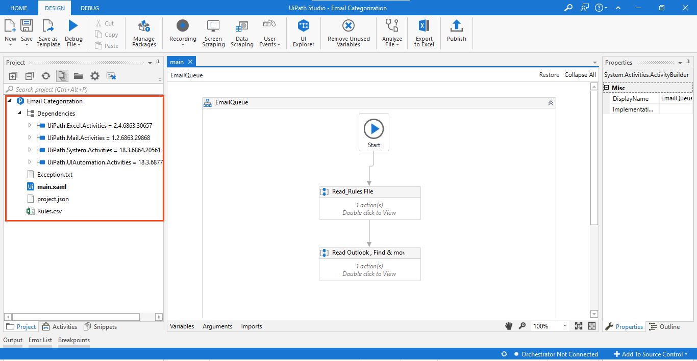

Figure 14 List of Packages installed in ‘Email Categorization.'

Right-click on "Dependencies" and select "Manage" to view all project dependencies (refer figure 15).

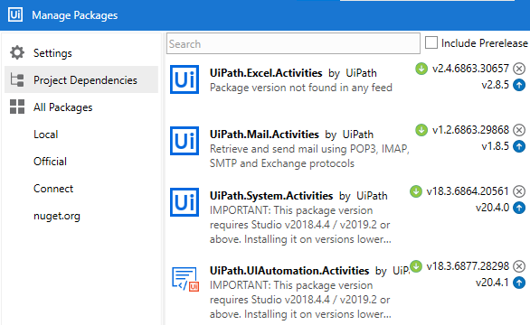

Figure 15 Project Dependencies ' Email Categorization'

**Note: If a package appears in 'Red' it indicates a problem. To resolve it, right-click on the package name and click resolve/update.**

**Prerequisite**

Outlook application should be configured on your device.

The Rules for the Robot are stored in an excel file ‘**Rules.xlsx’** in the Project folder.

The rules for categorizing emails are based on three parameters i.e.' From, Body, and Subject’ of the emails.

Ensure that emails should be unread and the folder should be created where we want to move the emails as per the rules in the ‘Rules.xlsx’ file.

* The Robot will use the predefined rules for the movement of incoming email to the respective folders such as Junk Email, Promotion, or Social.

Ensure that the ‘**Folder Path**’ is correctly mentioned in the ‘**Folder**’ column of the ‘**Rules.xlsx**' file. For, eg. In the folder ‘**Promotion’** is a sub-folder in Inbox, so the path has been mentioned as ‘**Inbox\Promotion’**.

## Process Flow

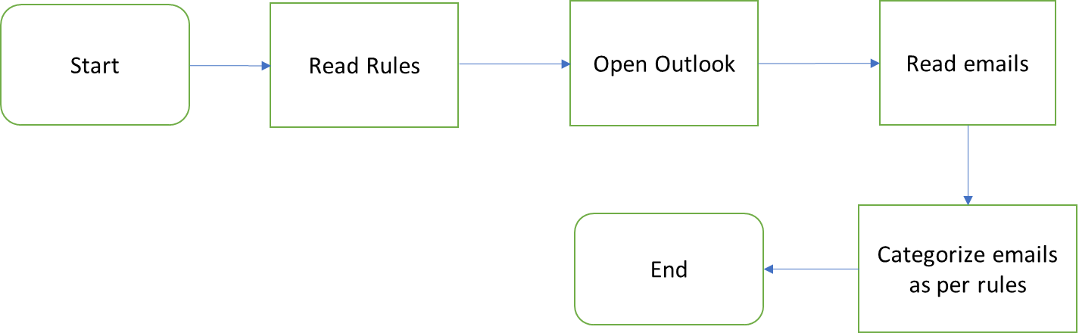

## Applications to be used



1. **UiPath Studio:** Used to create the Robot.
2. **Web Browser:** Used to extract data from different websites.
3. **MS Excel:** Used to store extracted data and create graph.

## Process steps

**Project Overview:** This project aims to build a robot for filtering and categorizing the emails automatically. The Robot opens Outlook application and then reads the unread emails from the inbox. After this, it filters the email according to a set of rules and conditions mentioned in the ‘Rules’ file.

The rules file has the below mentioned conditions based upon which the robot will perform actions:

* From
* Subject
* Email Body

## Steps to make an Email Categorization Robot:

Step 1: The Robot will open an email application, called Outlook.

Step 2: It will read and search for email on the basis of From, Subject, and Body of an email.

Step 3: It will categorize and move the identified emails as per the respective folders.

Step 4: It will close the outlook.